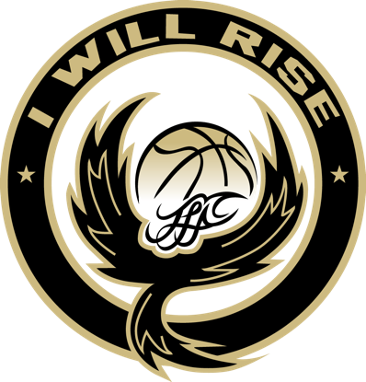
To Whom It May Concern:
Work It Out Inc (RISE) is a 501 (c)3 non-profit organization with a commitment to providing high quality and competitive basketball programs for children of all ages in Albuquerque, NM.
As you may know, it takes a lot of volunteering and financial support to make an organization
of this size a success. Registration fees are charged; however these fees alone do not cover all of a players or teams expenses. Funds received from your sponsors help to offset the athlete’s and/or team’s cost of uniforms, tournaments, equipment, and travel and supplement those funds provided by parents and from fundraising efforts. Your support is greatly appreciated by the parents, coaches, and administrative staff for our organization to succeed in providing a healthy and constructive activity for our youth.
Three options are available for sponsorship: 1) you may sponsor an individual player. All funds will be deposited directly to the players account; 2) you may sponsor a team. All funds will be deposited directly to the teams account to offset the expenses of the team and 3) you may give a donation to the Club. Any donations received by the Club will be used toward our financial assistance account for boys & girls that would like to participate in our program, but don’t have the financial means to do so at this time.
We appreciate you being a part of our success story by sponsoring a player, a team, or the Club during the 2022-23 season. If you have been an RISE player, team or corporate sponsor in the past, we would appreciate your support once again. If this is your first year, we welcome you to our organization.
Work It Out Inc (RISE) is a nonprofit organization (Tax ID #). Please keep a copy of this letter to use for tax purposes.
Please make all checks payable to Work it Out Inc and send to:
Make sure to note the team name, player name or note financial assistance account so that we can be sure these funds are given to the correct account.

